Univerzitet u Beogradu

Fakultet organizacionih nauka

Katedra za elektronsko poslovanje

ReactJS

Domaći zadatak 2

|  |  |  |
| --- | --- | --- |
| Ime | Prezime | Broj indeksa |
| Janko | Kovačević | 141/2018 |
| Link ka Github-u | https://github.com/jkovvv/iteh-react-quiz | |

Sadržaj

1 Korisnički zahtev 3

2 Implementacija 3

3 Korisničko uputstvo 21

# Korisnički zahtev

Aplikacija predstavlja kviz platformu koja omogućava korisnicima da odaberu različite kategorije kvizova, odgovaraju na pitanja, prate svoje rezultate, i vide konačnu ocenu. Pre pristupa kvizovima, korisnici se moraju prijaviti putem login stranice. Na home stranici korisnik bira kviz koji želi uraditi i započinje kviz. Nakon urađenog kviza korisnik dobija povratne informacije o broju tačnih odgovora i postignutom procentu (koji uračunava broj kao i brzinu klika na tačne odgovore).

# Implementacija

* **Komponente:**

|  |  |
| --- | --- |
| **Button.tsx** | import React from "react";  interface Props {    children: string;    color?: "primary" | "secondary" | "danger";    onClick: () => void;  }  const Button = ({ children, onClick, color = "primary" }: Props) => {    return (      <button        className={`button btn-${color}`}        onClick={onClick}        style={{ whiteSpace: "nowrap" }} // Sprečava prelamanje      >        {children}      </button>    );  };  export default Button; |
| **PrivateRoute.tsx** | import React from "react";  import { Navigate } from "react-router-dom";  import { useAuth } from "../context/AuthContext.tsx";  const PrivateRoute = ({ children }: { children: JSX.Element }) => {    const { isAuthenticated } = useAuth();    return isAuthenticated ? children : <Navigate to="/login" />;  };  export default PrivateRoute; |
| **QuestionCard.tsx** | import React from "react";  import Button from "./Button.tsx";  import Timer from "./Timer.tsx";  type QuestionCardProps = {    question: string;    options: string[];    onAnswerSelect: (option: string) => void;  };  const QuestionCard: React.FC<QuestionCardProps> = ({    question,    options,    onAnswerSelect,  }) => {    return (      <div className="question-card">        <h2>{question}</h2>        <div className="d-grid gap-2">          {options.map((option, index) => (            <Button key={index} onClick={() => onAnswerSelect(option)}>              {option}            </Button>          ))}        </div>      </div>    );  };  export default QuestionCard; |
| **QuizList.tsx** | import React, { useState } from "react";  interface Props {    items: string[];    onSelectItem: (item: string) => void;  }  function QuizList({ items, onSelectItem }: Props) {    const [selectedIndex, setSelectedIndex] = useState(-1);    return (      <>        <h1>Kvizovi</h1>        {items.length === 0 && <p>No item found</p>}        <ul className="list-group">          {items.map((item, index) => (            <li              className={                selectedIndex === index                  ? "list-group-item active"                  : "list-group-item"              }              key={item}              onClick={() => {                setSelectedIndex(index);                onSelectItem(item);              }}            >              {" "}              {item}{" "}            </li>          ))}        </ul>      </>    );  }  export default QuizList; |
| **Timer.tsx** | import React, {    forwardRef,    useEffect,    useImperativeHandle,    useRef,    useState,  } from "react";  type TimerProps = {    duration: number; // u milisekundama    onTimeUp: () => void;  };  export type TimerHandle = {    getTimeLeft: () => number;  };  const Timer = forwardRef<TimerHandle, TimerProps>(    ({ duration, onTimeUp }, ref) => {      const [timeLeft, setTimeLeft] = useState(duration);      const timerRef = useRef<number | null>(null);      useImperativeHandle(ref, () => ({        getTimeLeft: () => timeLeft,      }));      useEffect(() => {        if (timeLeft <= 0) {          onTimeUp();          return;        }        timerRef.current = window.setTimeout(() => {          setTimeLeft((prevTime) => prevTime - 40);        }, 40);        return () => {          if (timerRef.current) {            clearTimeout(timerRef.current);          }        };      }, [timeLeft, onTimeUp]);      return (        <div className="timer">          <span>            Time Left: {Math.floor(timeLeft / 1000)}.{(timeLeft % 1000) / 10}s          </span>        </div>      );    }  );  export default Timer; |
| **Toolbar.tsx** | import React from "react";  import { Link } from "react-router-dom";  import { useAuth } from "../context/AuthContext.tsx";  const Toolbar = () => {    const { isAuthenticated, logout } = useAuth();    return (      <nav className="navbar navbar-expand-lg navbar-light bg-primary">        {" "}        <div className="container-fluid">          <Link className="navbar-brand text-white" to="/">            {" "}            JKQuiz          </Link>          <div className="collapse navbar-collapse">            <ul className="navbar-nav me-auto mb-2 mb-lg-0">              <li className="nav-item">                <Link className="nav-link text-white" to="/">                  {" "}                  Home                </Link>              </li>            </ul>            {isAuthenticated && (              <button className="btn btn-outline-light" onClick={logout}>                {" "}                Logout              </button>            )}          </div>        </div>      </nav>    );  };  export default Toolbar; |

* **Stranice:**

|  |  |
| --- | --- |
| **HomePage.tsx** | import React, { useState } from "react";  import { useNavigate } from "react-router-dom";  import Button from "../components/Button.tsx";  import QuizList from "../components/QuizList.tsx";  //Kvizove ce uzeti iz bekenda kada projekti budu povezani, sada je sve hardkodovano  const quizzes = [    "Geografski kviz",    "Istorijski kviz",    "Muzicki kviz",    "Sportski kviz",    "TV kviz",  ];  const HomePage = () => {    const [selectedQuiz, setSelectedQuiz] = useState(null);    const navigate = useNavigate();    const onQuizSelect = (quizName) => {      setSelectedQuiz(quizName);    };    const handleButtonClick = () => {      if (selectedQuiz) {        console.log(`Odabran je: ${selectedQuiz}`);        navigate("/quiz");      } else {        console.log("Niste izabrali kviz");      }    };    return (      <div className="container mt-5">        <div className="row">          <div className="col-md-4">            <div className="card">              <div className="card-body">                <ul className="list-group">                  <QuizList items={quizzes} onSelectItem={onQuizSelect} />                </ul>              </div>            </div>          </div>          <div className="col-md-8 text-center">            <div className="card">              <div className="card-body">                <h1 className="display-4">Dobrodošli u kviz!</h1>                <p className="lead">Testirajte svoje znanje!</p>                <Button onClick={() => handleButtonClick()}>Započni kviz!</Button>              </div>            </div>          </div>        </div>      </div>    );  };  export default HomePage; |
| **LoginPage.tsx** | import React, { useState } from "react";  import { useAuth } from "../context/AuthContext.tsx";  import { useNavigate } from "react-router-dom";  const LoginPage = () => {    const [username, setUsername] = useState("");    const [password, setPassword] = useState("");    const { login } = useAuth();    const navigate = useNavigate();    const handleLogin = () => {      if (username && password) {        login();        navigate("/");      }    };    return (      <div className="container mt-5">        <div className="row justify-content-center">          <div className="col-md-6 text-center">            <div className="card">              <div className="card-body">                <h2 className="display-4">Prijavite se</h2>                <input                  type="text"                  className="form-control mt-3"                  placeholder="Korisničko ime"                  value={username}                  onChange={(e) => setUsername(e.target.value)}                />                <input                  type="password"                  className="form-control mt-3"                  placeholder="Lozinka"                  value={password}                  onChange={(e) => setPassword(e.target.value)}                />                <button className="btn btn-primary mt-3" onClick={handleLogin}>                  Prijavi se                </button>              </div>            </div>          </div>        </div>      </div>    );  };  export default LoginPage; |
| **QuizPage.tsx** | import React, { useState, useRef } from "react";  import { useNavigate } from "react-router-dom";  import QuestionCard from "../components/QuestionCard.tsx";  import Timer, { TimerHandle } from "../components/Timer.tsx";  const questions = [    {      question: "Probno pitanje 1?",      options: ["Ne", "Da", "Jok", "Nije"],      answer: "Da",    },    {      question: "Probno pitanje 2?",      options: ["Ne", "Da", "Jok", "Nije"],      answer: "Da",    },    {      question: "Probno pitanje 3?",      options: ["Ne", "Da", "Jok", "Nije"],      answer: "Da",    },    {      question: "Probno pitanje 4?",      options: ["Ne", "Da", "Jok", "Nije"],      answer: "Da",    },    {      question: "Probno pitanje 5?",      options: ["Ne", "Da", "Jok", "Nije"],      answer: "Da",    },  ];  const QuizPage = () => {    const [currentQuestionIndex, setCurrentQuestionIndex] = useState(0);    const [score, setScore] = useState(0);    const [points, setPoints] = useState(0);    const [maxPoints, setMaxPoints] = useState(0);    const navigate = useNavigate();    const timerRef = useRef<TimerHandle | null>(null);    const [refreshKey, setRefreshKey] = useState(0);    const checkAnswer = (option: string) => {      setMaxPoints(maxPoints + 5000);      if (option === questions[currentQuestionIndex].answer) {        setScore(score + 1);        if (timerRef.current) {          setPoints(points + timerRef.current?.getTimeLeft());        }      }      if (currentQuestionIndex < questions.length - 1) {        setCurrentQuestionIndex(currentQuestionIndex + 1);      } else {        navigate("/results", {          state: {            score:              score + (option === questions[currentQuestionIndex].answer ? 1 : 0),            points:              points +              (option === questions[currentQuestionIndex].answer &&              timerRef.current                ? timerRef.current?.getTimeLeft()                : 0),            maxPoints: maxPoints + 5000,          },        });      }    };    const handleAnswer = (option: string) => {      console.log(timerRef.current?.getTimeLeft());      setRefreshKey((prev) => prev + 1);      checkAnswer(option);    };    const { question, options } = questions[currentQuestionIndex];    return (      <div key={refreshKey} className="container mt-5">        <div className="row justify-content-center">          <div className="col-md-6">            <div className="card">              <div className="card-body text-center">                <h3 className="card-title">Pitanje {currentQuestionIndex + 1}</h3>                <QuestionCard                  question={question}                  options={options}                  onAnswerSelect={handleAnswer}                />                <Timer                  ref={timerRef}                  duration={5000} // 5 sekundi                  onTimeUp={() => console.log("Vreme je isteklo!")}                />              </div>            </div>          </div>        </div>      </div>    );  };  export default QuizPage; |
| **ResultsPage.tsx** | import React from "react";  import { useLocation, useNavigate } from "react-router-dom";  import Button from "../components/Button.tsx";  const ResultsPage = () => {    const location = useLocation();    const navigate = useNavigate();    const { score, points, maxPoints } = location.state || { score: 0 };    const calculateResults = (points: number, maxPoints: number) => {      let normalizedScore = (points * 100) / maxPoints;      normalizedScore = parseFloat(normalizedScore.toFixed(2));      return normalizedScore;    };    return (      <div className="container mt-5">        <div className="row justify-content-center">          <div className="col-md-6 text-center">            <div className="card">              <div className="card-body">                <h1 className="display-4">Broj tačnih odgovora: {score}</h1>                <h1 className="display-4">                  Tvoj rezultat: {calculateResults(points, maxPoints)}%                </h1>                <Button onClick={() => navigate("/")}>Igraj ponovo!</Button>              </div>            </div>          </div>        </div>      </div>    );  };  export default ResultsPage; |

* **App.js**

|  |  |
| --- | --- |
| **App.js** | import React from "react";  import { BrowserRouter as Router, Routes, Route } from "react-router-dom";  import HomePage from "./pages/HomePage.tsx";  import QuizPage from "./pages/QuizPage.tsx";  import ResultsPage from "./pages/ResultsPage.tsx";  import "bootstrap/dist/css/bootstrap.min.css";  import LoginPage from "./pages/LoginPage.tsx";  import PrivateRoute from "./components/PrivateRoute.tsx";  import { AuthProvider } from "./context/AuthContext.tsx";  import Toolbar from "./components/Toolbar.tsx";  import "./App.css";  const App = () => {    const backgroundStyle = {      backgroundImage: "url('/background.jpg')",      backgroundSize: "cover",      backgroundPosition: "center",      height: "100vh",      margin: 0,    };    return (      <div style={backgroundStyle}>        <AuthProvider>          <Router>            <Toolbar />            <Routes>              <Route path="/login" element={<LoginPage />} />              <Route                path="/"                element={                  <PrivateRoute>                    <HomePage />                  </PrivateRoute>                }              />              <Route                path="/quiz"                element={                  <PrivateRoute>                    <QuizPage />                  </PrivateRoute>                }              />              <Route                path="/results"                element={                  <PrivateRoute>                    <ResultsPage />                  </PrivateRoute>                }              />            </Routes>          </Router>        </AuthProvider>      </div>    );  };  export default App; |

* **Stilizacija:** za stilizaciju je korišćen Bootstrap, kao i ručno dodat css kod.

|  |  |
| --- | --- |
| **App.css** | body,  html {    margin: 0;    padding: 0;    height: 100%;  }  .card {    background-color: #ffffff;    border: 1px solid #dedede;    border-radius: 8px;    box-shadow: 0 2px 4px rgba(0, 0, 0, 0.1);  }  .question-card {    margin-bottom: 20px;  }  .d-grid {    display: grid;    grid-template-columns: repeat(2, 1fr);    gap: 10px;  }  .button {    padding: 10px 20px;    font-size: 16px;    font-weight: bold;    color: white;    background-color: #007bff;    border: none;    border-radius: 5px;    cursor: pointer;    transition: background-color 0.3s;  }  .button:hover {    background-color: #0056b3;  }  .list-group {    margin-top: 20px;  }  .list-group-item {    cursor: pointer;    transition: background-color 0.3s;  }  .list-group-item:hover {    background-color: #cce5ff;  }  .list-group-item.active {    background-color: #007bff;    color: white;  }  .container {    margin-top: 0 !important;  }  .col-md-4,  .col-md-6,  .col-md-8 {    margin-top: 30px;  }  .card {    background-color: rgba(255, 255, 255, 0.9);  }  /* App.css */  .navbar {    padding: 10px 20px;  }  .nav-link {    transition: color 0.3s;  }  .nav-link:hover {    color: #ffc107;  } |

* **AuthContext –** za login funkcionalnost korišćen je i AuthContext.tsx

|  |  |
| --- | --- |
| **AuthContext.tsx** | import React, { createContext, useState, useContext, ReactNode } from "react";  interface AuthContextProps {    isAuthenticated: boolean;    login: () => void;    logout: () => void;  }  const AuthContext = createContext<AuthContextProps | undefined>(undefined);  export const useAuth = () => {    const context = useContext(AuthContext);    if (!context) {      throw new Error("useAuth must be used within AuthProvider");    }    return context;  };  export const AuthProvider = ({ children }: { children: ReactNode }) => {    const [isAuthenticated, setIsAuthenticated] = useState<boolean>(false);    const login = () => setIsAuthenticated(true);    const logout = () => setIsAuthenticated(false);    return (      <AuthContext.Provider value={{ isAuthenticated, login, logout }}>        {children}      </AuthContext.Provider>    );  }; |

# Korisničko uputstvo

* **Login stranica:** Prvi ekran aplikacije, korisnici unose svoje podatke da bi se prijavili. Navigira na početnu stranicu.

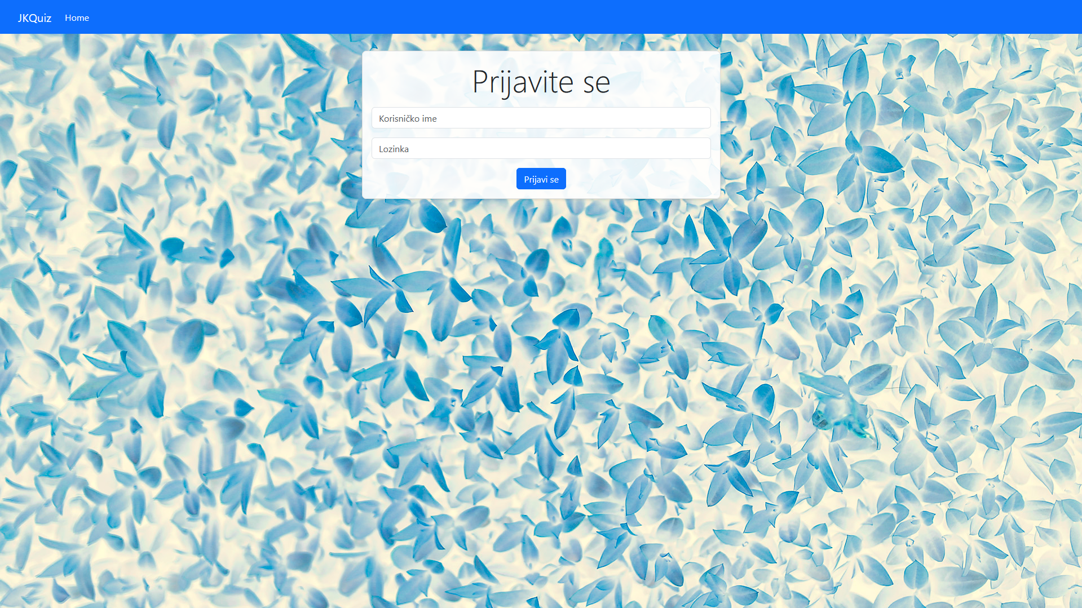

* **Početna stranica:** Korisnici biraju kviz iz liste kvizova. Navigira na stranicu kviza.

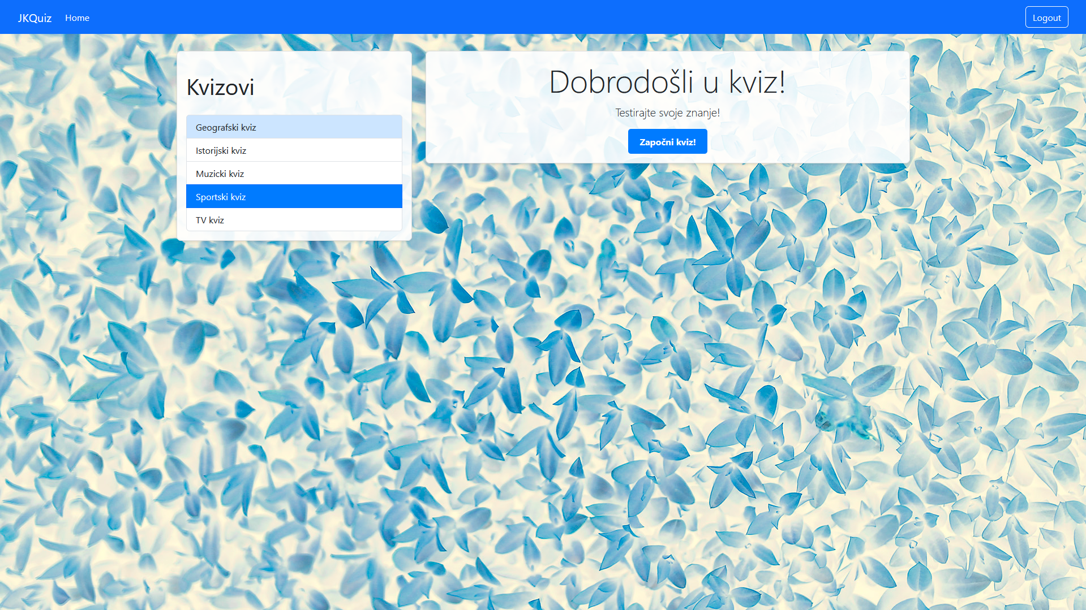

* **Stranica kviza:** Prikazuje pitanje sa 2x2 matricom dugmadi za odgovore i tajmerom. Nakon odgovorenog pitanja prelazi na sledeće pitanje. Na kraju testa navigira na stranicu sa rezultatima.

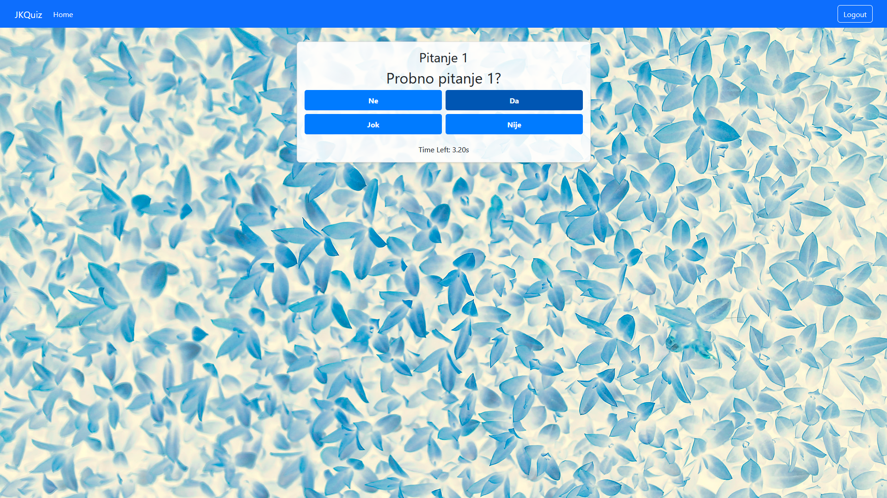

* **Stranica rezultata:** Prikazuje broj tačnih odgovora i procenat uspešnosti. Navigira nazad na početnu stranicu.

